**David Langen**

**October 31st, 2018**

Prince of Persia

Created by Jordan Rechner

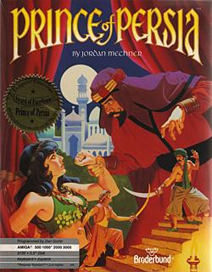

**Table of Contents**

**Game Outline**  
▪ Game Title  
▪ Intended game systems  
▪ Target age of players  
▪ Intended ESRB rating  
▪ Projected ship date  
• Game Outline  
▪ What are the challenges players encounter and the methods by which they  
can over-come them?  
▪ How does the progression/reward system work? How do players grow as  
the challenges increase?  
▪ How does the gameplay tie into the story? Do players encounter puzzles  
that grant access to new areas when solved? Do players have to fight  
bosses that bar their progression?  
▪ What is the victory condition for players? Save the universe? Kill all the  
enemies?  
▪ Collect 100 stars? All of the above?  
• Character(s)  
▪ Character’s backstory  
▪ Concept Art  
▪ Character controls  
• Gameplay  
▪ How is the game divided? By levels or rounds?  
▪ Minigames  
▪  
**• Game World**  
▪ List environments  
▪ Music used in game world  
▪ Present some images and descriptions of the game world  
• Game Experience  
▪ What do players first see when they start the game?  
▪ What emotions/moods are meant to be invoked by your game?  
▪ How are music and sound used to convey your game’s feel?  
▪ How do players navigate the shell of the game? Include flowchart diagram  
• Gameplay Mechanics  
▪ Mechanics (item or element that players interact with to create or aid with  
gameplay  
▪ Hazards \  
• Enemies  
▪ Boss characters  
• Multiplayer and Bonus Materials  
▪ Any bonus materials  
▪ Does your game offer multiplayer?  
▪ Can players create and share their own content?  
• Monetization

**Game Outline**

* Prince of Persia has become a franchise, developed and published by Broderbun and created by Jordan Mechner, with the help of Ubisoft and is intended for all-ages, and now, old school players, which provides a fantasy, cinematic 1D platform and was originally intended to be a project designed for the Apple II. The rating was Mature as it was developed in 1989, gamers were just getting used to the image of violence on a screen which they controlled. The target age of players would have been Teen and up.
* The game was set back in time, where an eponymous warrior Prince was to escape the dungeons and make it to the palace, through rough terrain, whilst avoiding devastating obstacles, and defeating warriors of the palace, along with the undead in order to free the princess of her enslavement. It had numerous levels and stages of difficulty, with backgrounds ranging from the dungeons to the tip of the tower, where you’d find a chamber where the princess was eventually unveiled, (not literally).
* The game used “rotoscoping” which is a technique where the artist would develop picture and then layer pictures on top of it, as does some of the older animated films. This created a balance of fluidity to created a realistic atmosphere through its animation process. Rechner actually used his brother to perform acrobatic moves as he drew them out and developed them into the game.
* With Prince of Persia, your skills had to grow as the game went on, as it didn’t have many upgrading solutions. You were set with 5 health points, to my knowledge and had the ability to find additional health points throughout the level, or by defeating enemies.
* The controls for the game were quite simple. You’d generally start by walking left to right, with a sword in your hand. Within the game you were required to re-track steps in order to unlock puzzles, which would open doors to boss enemies. The running jump was a highly used move in the game, as the obstacles (spike pit, bear trap, acid etc), would require more distance to leap across. The running start would allow you to do so. Other than that, the basic controls were for swinging your sword at enemies, with the option to block or attack, trying to land a blow, or at least block a shot, to jump, swing on ropes, and crouch, (which was useful for finding hidden health points, and remaining stealthy.
* The game required a lot of patience, but you need to take risks as well, as you are given only 60 minutes to complete the game. You are required to restart the game after your character lost his final breath. This required a mastering of the game, where in the more difficult levels, you’d be forced to fight multiple enemies, at the same time, with pits on either side of you, or slamming spiked doors, with cause for an immediate death. Although this linear classic was short and sweet, finding your way to the final boss, and losing, was grounds for detention from your parents. I for one used to toss the mouse, sometimes it broke.

**Tus (Prince of Persia)**

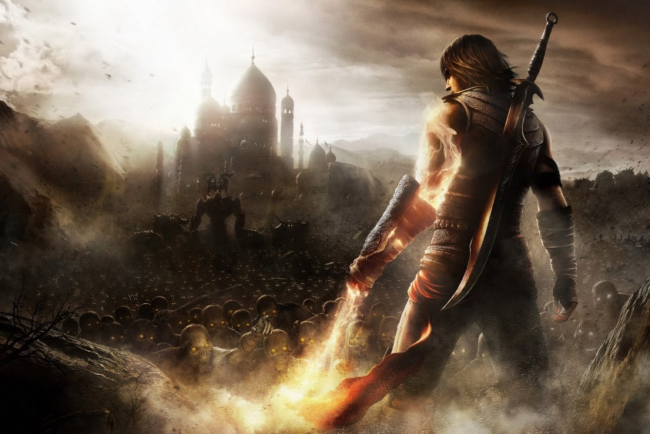

Tus is the main character in the game. He is the Prince, in search of saving the Princess as he bravely makes his way through fighting and eluding, risking his life.

**Princess Tamina**

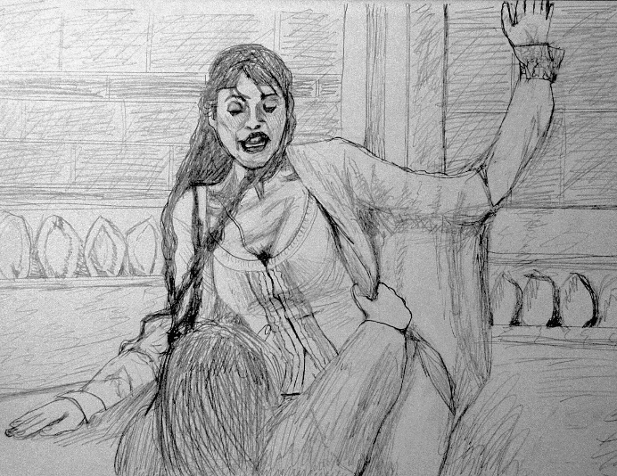

Princess Tamina is the Tus’ eternal love. She has been kidnapped by Jaffar and awaits the Sultan Prince to escape the dungeons and find his way to here where she remains trapped in the Sultan tower.

.

**Jaffar**

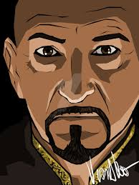

Jaffar is the original villain in the Prince of Persia series. He is to be wed in 60 minutes (the time allotted in the game for Tus’ escape in order to stop the marriage.

**Sultan Warrior**

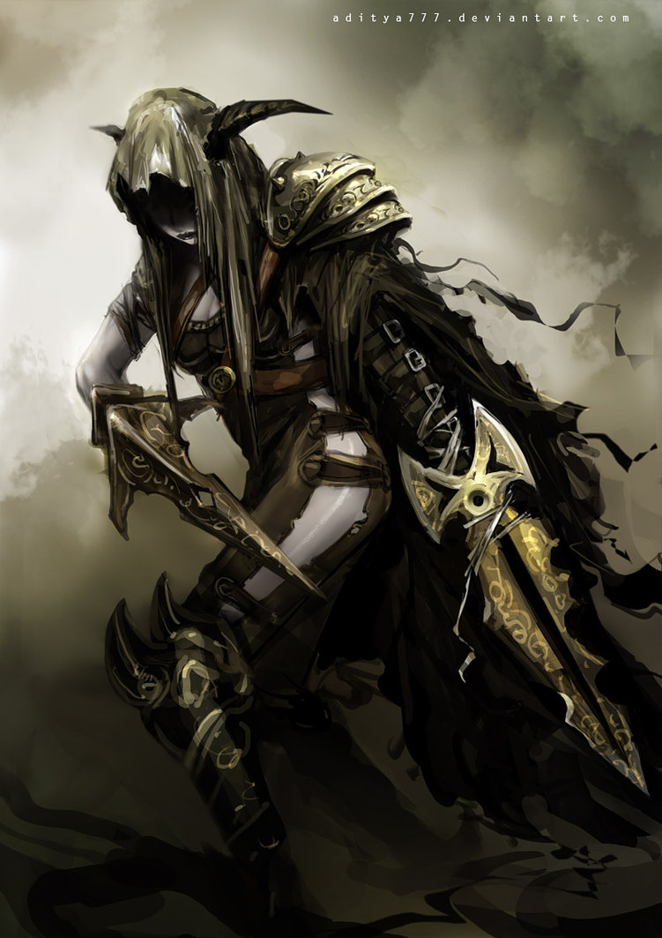

The Sultan Warriors are the more difficult enemies in the game. As they take command under Jaffar, they start to become a nuisance as you may have to battle up to four at the same time, depending on your strategies.

**Skeletal Warrior**

The Skeletal Warrior’s are a pain in the ass as you move along the game. Primarily in the dungeon sequences at the beginning, they will also rarely appear in the later levels in the palace.

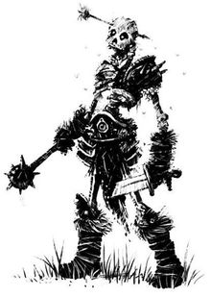

**Doppleganger**

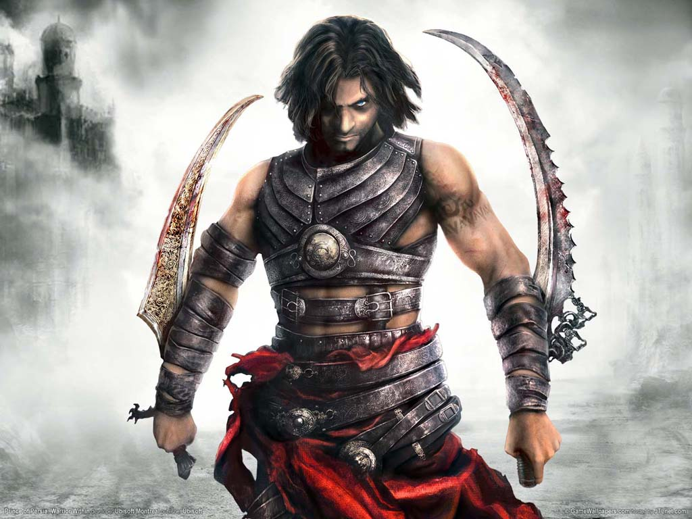

The Doppleganger is a mirrored reflection of the Prince. He moves swiftly, and quickly, and is the boss to beat in order to make your way through to Jaffar.

Gameplay World

* The environments in the game are quite intriguing without the need of many background effects. The music fits gameplay as it should, with a high stress level as your character loses health. The audio typically stays the same other that the changes between dungeon and palace. The sound effects are on par, while swords clash, or the prince slides, or even worse, falls into a spike pit causing an agonizing death for the character, and an overwhelming 37th attempt (37 hours) to get through to the end.

 

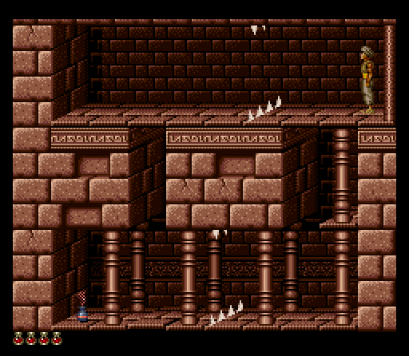

* When players first start the game they are met with a home screen with Arabic music playing lightly in the background. You can select either “start game” or “options”. To my knowledge you cannot change the difficulty level, so as I explained before, getting used to the controls, and reflexes is important.
* The game experience is quite engaging. It is a game that will keep your eyes locked until you have completed it. Again, I feel this game has potentially created serial killers, as the difficulty level is high, and the restart is terribly frustrating.
* The game mechanics are limited. As there isn’t much of a reward system, and the game is linear, other than jumping and fighting, the game demands timing if you have any chance of completing it. Your purpose of course is to rescue the princess.
* The hazards include, spike pits, slamming door, falling ceiling bits, broken floor panels etc. The enemies are just your standard skeletal warriors and Sultan Warriors. The only boss character in the game other than Jaffar, who you do not have to fight, is your doppleganger, who is slick and attempts to mirror your every move, which creates a high level of stress and irritation. There is no multiplayer option, but I do believe there are stats for fastest time completed within the 60 minutes. Players cannot create and share their own content, which makes sense for the game, as I believe its one of the Old School staples, and is one of the video games that got me connected to the virtual world.
* The game franchise includes, Prince of Persia, Prince of Persia 2: The Shadow and the Flame, Prince of Persia 3d, the original trio, which were developed for PC. Following the original success, Prince of Persia: The Sands of Time collection cam to market. which was also made into a movie starring Jake Gyllenhaal. The Sands of Time Collection were made available for Sony and Microsoft. Prince of Persia is the highest grossing video game turned movie of all time. The gross total for the games has proven difficult to find.

